

EUROPEAN CITIZENS AND INTELLECTUAL PROPERTY:
PERCEPTION, AWARENESS, AND BEHAVIOUR
EXECUTIVE SUMMARY



EUROPEAN CITIZENS AND
INTELLECTUAL PROPERTY:
PERCEPTION, AWARENESS,
AND BEHAVIOUR
EXECUTIVE SUMMARY

FIELDWORK: From 21 to 28 October 2016
PUBLICATION: 23 March 2017
The European Union Intellectual Property Office commissioned Deloitte to carry out the study.

Contents
FOREWORD 4
EXECUTIVE SUMMARY 6
EUROPEANS´AWARENESS OF, AND THEIR ATTITUDES TOWARDS IP 7
COUNTERFEITING 10
DIGITAL CONTENT 15

FOREWORD
European Citizens and Intellectual Property: Perception, Awareness, and Behaviour

This survey updates the first perception study published by the Observatory in 2013, and provides further evidence of how IP rights (IPR) are perceived by EU citizens at a time when encouraging innovation and creativity is increasingly the focus of economic policy.
This EU-wide study, covering residents in all EU Member States aged 15 years and over and bringing together the results of more than 26 000 interviews, confirms generally the global picture assessed in 2013. Even during a period of economic crisis when household budgets have come under pressure, 97 % of those surveyed agree that it is important that inventors, creators and performing artists can protect their rights and be paid for their work.
Moreover, 70 % of Europeans surveyed believe that nothing can justify the purchase of counterfeit goods and 78 % consider that buying counterfeits ruins business and jobs. This latter point is supported by other studies carried out through the Observatory on the economic impact of IP rights and the damage caused by infringements to jobs and income in legitimate businesses.
A clear preference emerges for using legal means to access online content when an affordable option is available (83 %). A growing proportion, some 27 %, say they have paid to access digital content, which is 7 percentage points higher than in the previous study and 41 % of young people, are also buying online content using lawful channels, which is 8 percentage points higher than before.
However, in line with the 2013 results, people do not always act in line with their stated position. The key 15-24 age group seems to have become less convinced that fake goods are damaging and is buying more counterfeit goods, mainly for price reasons.
Among respondents admitting to using illegal sources, price and availability from legal sources prevail as the main drivers for such behaviour, as 31 % of respondents believe that it is acceptable to obtain content illegally when there is no immediately available legal alternative. However, even though about 69 % of citizens agree that lawful services offer higher quality content, only 54% consider they offer more diversity than illegal sources. The study showed that the level of illegal downloading or streaming of copyright material remains stable.
Furthermore, it is worth noting that citizens are more confused. Around 10 % of respondents said they were misled when buying products, while 35 % were unsure if the product they had bought was genuine or counterfeit. With regard to downloading or streaming, 24 % of respondents wondered if a source was legal and for young people the proportion who were confused on this question rose to 41 %.
These findings demonstrate the need for initiatives carried out by the Observatory, such as the European Online Content Portal, agorateka, the Ideas Powered website, including the publication of Frequently Asked Questions on copyright, and the Office’s support for the setting up of Europol’s IPR Crime Coordination Centre, which, among other activities, pays particular attention to the phenomenon of online IPR infringements.
Overall, this latest study shows that support for IP rights continues to be high among citizens even though there is still room for improvement in helping young people in particular to understand the economic logic of IP and the social impact of infringements. Despite the growing use of legal offers, there still seems to be a perception that the market is not providing services that meet the expectations of this age group in terms of price and affordability.

Against this background, the trilogy of studies covering the economic contribution of IP to the EU; the perception of EU citizens; and the economic cost of infringement will continue to have a vital role to play in the years ahead, by providing policymakers, businesses and citizens with impartial facts on which to base the debate on the way forward.

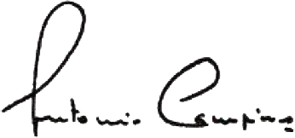
António CAMPINOS
EUIPO Executive Director

EXECUTIVE SUMMARY
European Citizens and Intellectual Property: Perception, Awareness, and Behaviour

In 2013, the European Union Intellectual Property Office commissioned the study, European Citizens and Intellectual Property: Perception, Awareness and Behaviour, to explore Europeans’ attitudes towards IP; the degree to which Europeans respect these rights, and the concept as a whole. This study, which was conducted in 2016, gives an updated analysis and makes a comparison with the results of the 2013 study, based on a new quantitative survey and a literature review. It covers the population of the respective nationalities of the EU Member States, and residents in each of the 28 Member States aged 15 or over. In total, 26 555 interviews were carried out.
Eighty per cent of the questionnaire was similar to the 2013 study, in order to allow comparisons to be made with the 2013 results and thus to identify trends. New questions were integrated, in order to allow further exploration into perspectives that the 2013 survey had revealed and to follow their evolution.

EUROPEANS´AWARENESS OF, AND THEIR ATTITUDES TOWARDS IP
European Citizens and Intellectual Property: Perception, Awareness, and Behaviour

GENERAL SUBJECTIVE UNDERSTANDING OF IP INCREASES; HOWEVER, IT DECREASES AMONG THE YOUNGER GENERATION

Overall subjective understanding of IP increased compared with 2013; however, this overall increase hides some discrepancies. While the percentage of the Europeans surveyed who say they have a ‘rather good’ understanding of IP increased by 10 points, there appears to be a reduction in the level of understanding, as the proportion of respondents with a ‘very good’ understanding decreases.
Note: (+ xx) (– xx) (=) shows how the results have evolved since 2013.

Very poor
Very good
Rather good
Rather poor
Total ‘Good’
75%
Do not know / Not applicable
(+2)
(+10)
(-8)
Sub-total of positive answers
(very good + rather good)

It is worth noting that the total ‘good’ understanding has increased since 2013 among participants aged 25 to 54 (+ 5 points) and remains steady among respondents who are 55 or over. However, among the youngest respondents, the picture is different. Just as in 2013, the youngest generation reports the lowest level of ‘good’ understanding in comparison with other age groups, and this level of understanding is decreasing: 64 % of the Europeans surveyed aged 15 to 24 report an overall good understanding of IP, compared with 68 % in 2013.

RECOGNITION OF THE ROLE OF IP IN PROTECTING THE RIGHTS OF INVENTORS, CREATORS, AND ARTISTS IS INCREASING

The importance of protecting IP is increasingly acknowledged, as almost all respondents believe it is important that inventors, creators and artists are able to protect their rights and be paid for their work. This belief reveals an attachment to the principles and recognition of the benefits of protecting IPR.

(+1)
Total Agree
97%
It is important that inventors, creators and performing artists could protect their rights and be paid for their work
(+5)

Tend to agree
Totally agree

LARGE MAJORITY OF EUROPEANS ACKNOWLEDGE IP AS A PILLAR FOR ECONOMIC STABILITY, ALBEIT WITH SOME LIMITATIONS

The percentage of the respondents who equate IP protection with maintaining economic stability remains stable, at 67 %. Additionally, two thirds of respondents recognise the role of IP-intensive companies in the creation of jobs, although agreement decreases slightly compared with 2013. However, half of the Europeans surveyed believe that strict protection of IP may curb innovation, and more than half feel that IP principles are not adapted to the internet .

 | Agree that  if there was no longer any IP protection there would be economic chaos |  | Agree that  companies that create a lot of IP contribute significantly more than the others to the creation of jobs or growth
 | NEW | Agree that  strict protection of IP may curb innovation | NEW | Agree that  IP principles are not adapted to the Internet

Just as in 2013, the opinion associating the absence of IP rules with economic chaos is most prevalent among the youngest and oldest age groups: 73 % of respondents aged 15 to 24 and 70 % of those aged 55 or over share this belief. Interestingly, and consistently since 2013, the most-educated Europeans are less convinced by this impact (63 %), and the level of understanding of IP does not play any role in this belief.
The opinion of IP curbing innovation appears to be more widespread among the youngest Europeans surveyed: 6 out of 10 respondents aged 15 to 24 agree with this statement (59 %, versus the EU average of 50 %). It is also a frequent belief among buyers of counterfeit products and people downloading or streaming from illegal sources, 57 % of this sub-group agree with this statement.

IP REMAINS A LARGELY ABSTRACT CONCEPT FOR CITIZENS, WITH ALMOST HALF BELIEVING THAT ‘ELITES’ BENEFIT THE MOST FROM IP PROTECTION

IP remains a largely abstract concept for citizens, as there is a continuing trend of associating IP protection with the ‘elite’, such as large companies and famous artists. More than 4 out of 10 Europeans surveyed believe that these groups benefit the most from IP. At the same time, respondents think that consumers like themselves benefit to a much lesser extent. This pattern was the same in 2013.

Big companies: | 24% | (-1)
Famous performing artists: | 20% | (+3)
Consumers like yourself: | 5% | (+1)
Small and medium companies: | 3% | (=)
Big companies + Famous artists | 44%

While overall the results are similar between the 2013 and 2016 surveys, a shift occurs when considering age groups. In 2013, the belief that large companies and famous artists were the main beneficiaries of IP was more concentrated among young Europeans. In 2016, however, this belief spans across age groups: 40 % aged 15 to 24 (– 7 points), 47 % aged 25 to 39 (unchanged from the 2013 study), 49 % aged 40 to 54 (+ 5 points), and 40 % of respondents aged 55 or over (+ 4 points).

COUNTERFEITING
European Citizens and Intellectual Property: Perception, Awareness, and Behaviour

CONTINUING STRONG CONDEMNATION OF THE PURCHASE OF COUNTERFEIT GOODS, BUT A SHIFT TOWARDS INCREASING ACCEPTANCE

The Europeans surveyed continue to regard IP as a fundamental value, which is closely linked to strong condemnation of purchasing counterfeit products. Seven out of ten Europeans surveyed believe that nothing can justify the purchase of counterfeit goods. This strong condemnation is further confirmed, as the proportion voicing the strongest attitude, ‘totally disagree’, is between 49% and 59 % for all the statements from the survey shown below.
=
(+1)
(-5)
(-1)

(+3)
(-7)
(+1)
(+3)
(+3)
=
(-2)
(-2)
(-2)
(+6)
=
=
(+6)
(+3)
(+1)
(+2)

However, although condemnation of counterfeiting remains high acceptance of the practice is increasing, especially when the reasons for buying counterfeits are price and availability.

THE MAJORITY BELIEVE THAT COUNTERFEITS DAMAGE THE ECONOMY, WHILE THEY PERCEIVED IMPACT ON INNOVATION IS WEAKER

As in 2013, out of the four arguments tested, (negative impact on the economy, encouraging illegal trafficking, threat to public health and discouraging innovation), the economic factor continues to discourage purchasing of counterfeit products the most, as 78 % (– 3 points) of respondents believe that purchasing counterfeit products ruins businesses and jobs and only 20 % do not share this opinion. However, the proportion of those who do not acknowledge the damage of counterfeiting is increasing.
The negative impact of purchasing counterfeit products on innovation is the least-accepted argument overall when considering all four arguments tested and is even less evident to the Europeans surveyed in 2016 than it was in 2013. Almost half of the Europeans surveyed (48 %) do not believe that purchasing counterfeit products discourages innovation.

 | Total Disagree |  | Totally disagree |  | Tend to disagree |  | Tend to agree |  | Totally agree | DK | Total Agree
Buying counterfeit products ruins businesses and jobs | 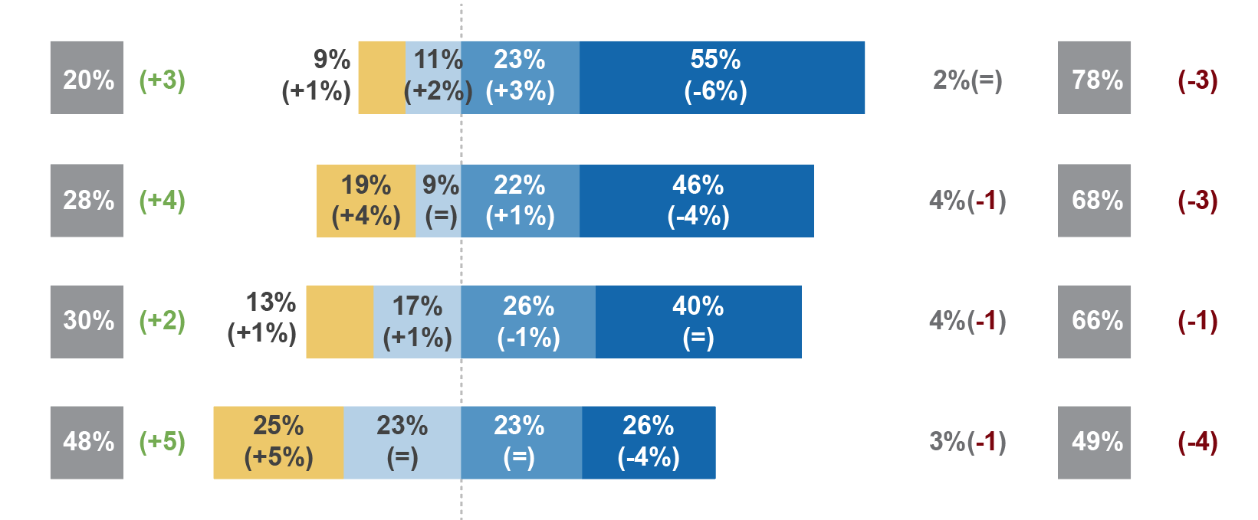
Buying counterfeit products supports child labour and illegal trafficking
Buying counterfeit products poses a threat to health
Buying counterfeit products discourages companies from inventing new products and introducing them to the market

DECLARED PURCHASE OF COUNTERFEIT GOODS REMAINS LOW, BUT INCREASES, ESPECIALLY AMONG THE YOUNGER GENERATION

Overall, the percentage of the Europeans surveyed who declare intentionally purchasing counterfeit products remains low, but has increased 3 points since 2013 (7 % versus 4 % in 2013). Among those who admit having intentionally purchased counterfeit products, there is an observable over-representation of youth, as 15 % of the participants aged 15 to 24 admit having intentionally engaged in such behaviour (+ 9 points), compared to the European average of 7 % and only 4 % of respondents aged 55 or over.
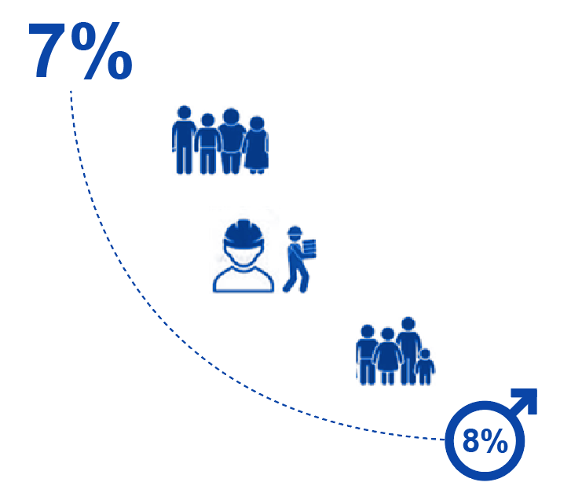
Bought counterfeit products intentionally

+ aged 15-24: 15% (+9)

+ manual workers: 11% (+6)

+ aged 25-39: 9% (+4)

(+3)

Meaning…
15% of 15-24 have intentionally purchased a counterfeit product, vs. 7% in the total EU population
PURCHASE OF COUNTERFEIT GOODS AS A RESULT OF BEING MISLED ALSO REMAINS LOW, BUT INCREASES, ESPECIALLY FOR MANUAL WORKERS AND THE SELF-EMPLOYED

Those who were misled into purchasing counterfeit goods also increased by 4 points (10 % v 6 % in 2013).

10% | bought counterfeit products as a result of being misled | (-4)

While in 2013, the youngest generation was the most likely to have purchased counterfeit products as a result of being misled, in this survey, respondents aged 25 to 39 who display this behaviour at a higher rate. In total, 12 % aged 25 to 39 say they have purchased counterfeit products due to being misled (+6 points), whereas 11 % of respondents aged 15 to 24 admit the same behaviour (+ 4 points).
While more Europeans surveyed are purchasing counterfeit goods, a notable proportion (35 %) have also wondered whether a product they purchased was genuine or counterfeit.

CITIZENS SURVEYED DECREASINGLY RATIONALISE PURCHASING COUNTERFEIT PRODUCTS AS ‘A SMART PURCHASE’ OR ‘AN ACT OF PROTEST’

While the level of acknowledgement of the negative impact of purchasing counterfeit products decreases and counterfeit purchasing behaviour increases, the rationalisation for purchasing counterfeit products to improve one’s purchasing power, or as an act of protest, also decreases.
Of the Europeans surveyed, 34 % (‒ 4 points) consider purchasing counterfeits as an act of protest, while 62 % do not share this opinion. Furthermore, Europeans also decreasingly view the act of purchasing counterfeits as one of resourcefulness is less prevalent, as the percentage of Europeans interviewed who consider buying counterfeits a smart purchase that can preserve one’s purchasing power decreases compared with 2013 (30 %, ‒ 4 points).

 | Total Disagree |  | Totally disagree |  | Tend to disagree |  | Tend to agree |  | Totally agree | DK | Total Agree
Buying counterfeit products is an act of protest and a way to resist to the market-driven economy and the large premium brands | 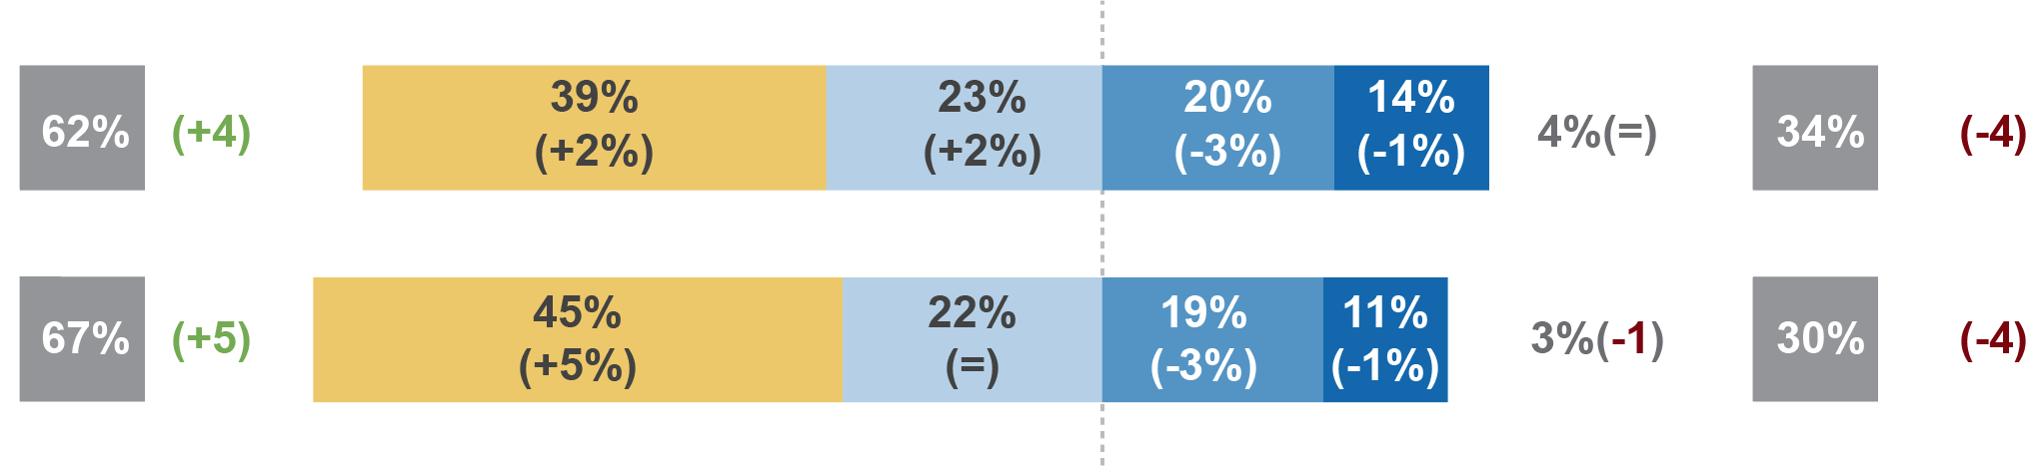
Buying counterfeit products allows making a smart purchase that enables you to have the items that you wanted while preserving your purchasing power

As regards viewing counterfeit goods purchases both as a way of preserving purchasing power and as a way to protest against the market-driven economy, it is the youth and manual workers who are most likely to support these ideas, a continuing trend from the 2013 survey. However, while these groups are the most likely to justify counterfeit products purchasing based on resourcefulness and as an act of protest, it is noted that agreement with both ideas decreases among both groups compared with 2013.

INCREASED AVAILABILITY OF AFFORDABLE PRODUCTS WOULD MAKE BUYERS STOP PURCHASING COUNTERFEIT GOODS

Among respondents who admit having intentionally purchased counterfeit goods, the impact of this behaviour on the EU economy or the harm caused to the producers of the original content does not appear to make a significant impression. Just as the increase in acceptability of counterfeits appears to be driven by price, the same is observed regarding those who have intentionally purchased a counterfeit product within the last 12 months. The availability of affordable products is the main reason that would make counterfeit buyers discontinues this behaviour, ahead of a personal bad experience and the risk of punishment.

As regards the main reason that would make the Europeans surveyed stop purchasing counterfeit products, respondents aged 15 to 24 stand out, as 72 % of the younger generation attribute the behaviour to price, compared with 58 % of respondents aged 55 or over. Additionally, the most-educated respondents (65 %), men (65 %) and manual workers (67 %) are also the most likely to cite availability of affordable products as the primary reason that would make them stop purchasing counterfeit products.

DIGITAL CONTENT
European Citizens and Intellectual Property: Perception, Awareness, and Behaviour

GENERAL ACCEPTABILITY OF COPYRIGHT INFRINGEMENT DECREASES, ALTHOUGH ACCEPTABILITY OF DOWNLOADING/STREAMING FROM ILLEGAL SOURCES WHEN THERE IS NO LEGAL ALTERNATIVE INCREASES

While general acceptability of copyright-infringement behaviour decreases, with only 35 % of respondents believing it is acceptable to obtain online content illegally if it is for personal use (– 7 points), consumption needs appear to increasingly overrule legal concerns, as 31 % (+ 9 points) of the Europeans surveyed state that obtaining online content via illegal sources is acceptable if no legal alternative is available.
Total Agree
It is acceptable to obtain content illegally from the Internet when there is no immediately available legal alternative
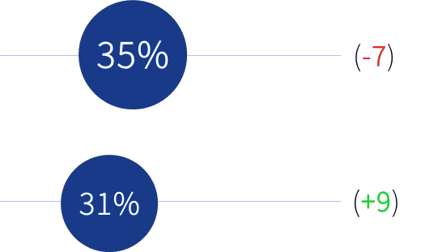
It is acceptable to obtain content illegally from the Internet when it is for my personal use

The level of acceptability of illegal downloading when there is no immediately available legal alternative decreases with age. However, compared with 2013, there is an observable reduction of the gap between the younger and older generations. In 2013, the gap between the youngest Europeans surveyed and the oldest was 31 points, whereas in 2016, this gap shrank to only 19 points. It appears that as older Europeans increasingly access digital content, their acceptability of using illegal sources also increases when there is no immediately available alternative.

INCREASING PREFERENCE FOR LEGAL SOURCES OVER ILLEGAL ONES

Even though an increasing proportion of the citizens surveyed state that infringing behaviour can be justified when no legal alternative is available, a large and increasing majority of the Europeans surveyed would choose the legal offer over illegal sources. There is a clear preference for using legal means to access online content when an affordable option is available, as 83 % of the Europeans surveyed say they prefer to obtain digital content through legal/authorised services and not to use illegal means.

Total Agree
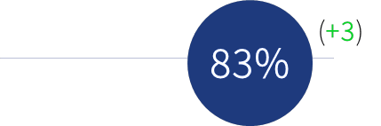
Whenever there is an affordable legal option I prefer to access/download/stream content through authorised platforms and do not access/download/stream illegally

Only 8 % declare they would not necessarily go for the legal option even if it were an available and affordable option. This proportion is much higher among copyright infringers, with 15 % of buyers of counterfeit products and 20 % of people downloading or streaming illegally expressing this opinion. It is also shared among the youngest Europeans surveyed. Among the 15 to 24-years olds, 13 % would still use the illegal option. However, this proportion has dropped by 4 points from 2013, whereas it has decreased by 2 points overall. This decline is consistent with the increase in the use of lawful services by the youngest Europeans.

INCREASE IN THE USE OF LEGAL SERVICES

Preference for obtaining content through legal means is shown by a growing number of the Europeans surveyed reporting using legal offers. In total, 27 % (+ 7 points) of the Europeans surveyed have paid to access digital content.
As regards respondents who say they have paid to access content online, youth, urban dwellers and men appear to drive this evolution. 41 % of those aged 15 to 24 (+ 8 points), 41 % of respondents aged 25 to 39 (+ 12 points), 30 % of respondents living in large towns (+ 7 points), and 32 % of men (+ 8 points) have paid to use a lawful service to access digital content.
Paid to access, download or stream copyright protected content from a lawful service on the Internet (music, video, film or TV series)
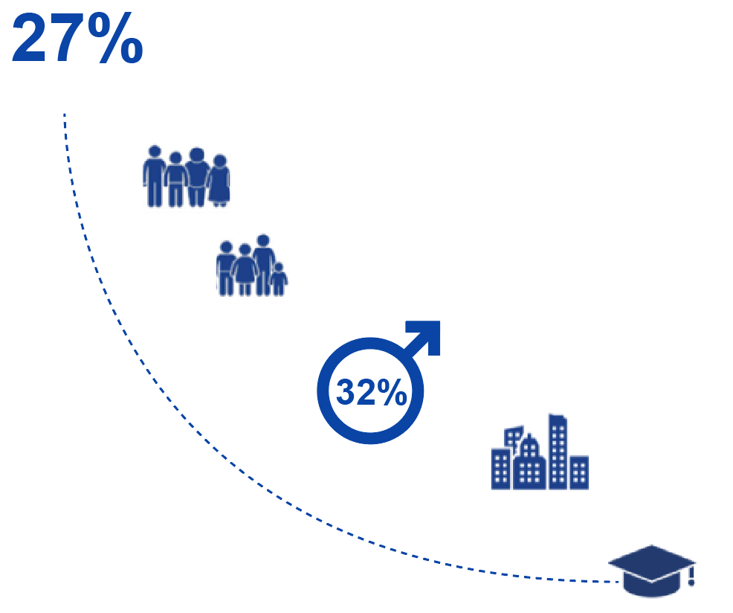
Meaning…
41% of 15-24 years-old have paid to access, download or stream copyright protected content from a lawful service vs. 27% in the total EU population

+ most educated (end of education after 20): 32% (+8)
+ living in large towns: 30% (+7)
(+8)
+ aged 15-24: 41% (+8)
+ aged 15-24: 41% (+8)

Additionally, the most-educated respondents also have an impact on the evolution since 2013, as 32 % of these respondents (+ 8 points) have paid to access content via a lawful service online.
THE INCREASE IN THE PREFERENCE FOR AND USE OF LEGAL SOURCES HAS NOT YET LED TO A DECREASE IN THE USE OF ILLEGAL ONES

A minority of the Europeans surveyed, 10 % (+ 1 point), say they have intentionally used illegal sources online. While the younger generations are the most likely to have paid to access content, they are also the most likely to have intentionally accessed content using illegal sources, with the most significant increase among respondents aged 25 to 39: 27 % of participants aged 15 to 24 (+ 1 point) and 18 % of those aged 25 to 39 (+ 4 points).

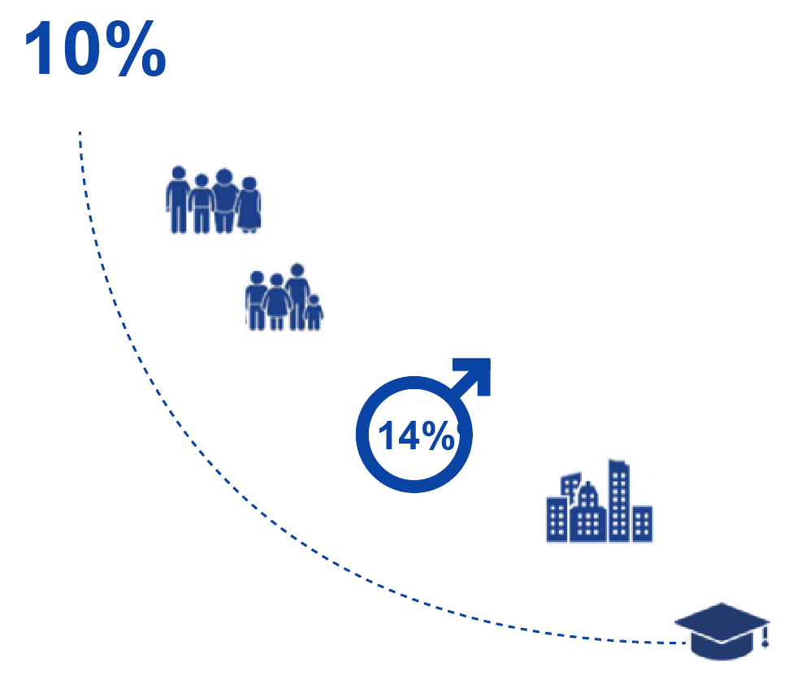
Meaning…
27% of 15-24 have accessed or downloaded or streamed content from illegal online sources vs. 10% in the total EU population
(+1)
+ living in large towns: 13%
Accessed or downloaded or streamed content from illegal online sources intentionally
+ most educated (end of education after 20): 11% (+1)

(+1)
+ aged 25-39: 18% (+4)
+ aged 15-24: 27% (+1)

(+1)

NEED FOR CONSUMPTION APPEARS TO PREVAIL OVER LEGAL CONSIDERATIONS

Approximately one third (32 %) of the Europeans surveyed accessed copyright content online, legally or illegally, with 22 % using only lawful services, 5 % using only illegal sources and 5 % using a mix of paid lawful and illegal sources. This suggests that respondents are willing to switch between legal and illegal sources in order to gain access to content.

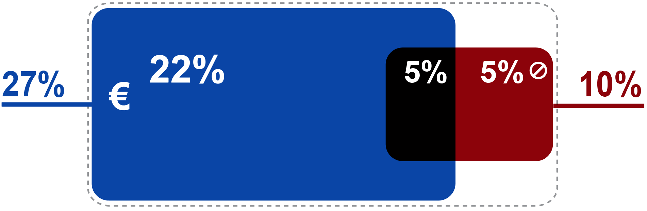
of Europeans paid for lawful sources

of Europeans used illegal sources
ONLY paid for lawful services

used ONLY illegal sources

mixed paid lawful and illegal sources

CONFUSION IS GROWING ABOUT WHAT CONSTITUTES A LEGAL OR ILLEGAL SOURCE

While use of lawful sources has increased, so has awareness of the legality of online content; however, there appears to be increased ambiguity regarding what constitutes a legal or illegal offer. A total of 24 % of the Europeans surveyed questioned whether a source was legal or not with, a 5 point increase compared with the 2013 study; and 4 % of the Europeans surveyed say they have investigated to check whether a source was legal or not, with a 2 point increase.

24%  (+5) | Wondered if a source where you could download music or video was legal or not

14%  (+2) | Researched to check if a source where you could download music or videos was legal or not

THE SUPERIOR QUALITY OF LEGAL OFFERS IS ACKNOWLEDGED BY A MAJORITY OF THE EUROPEANS SURVEYED, BUT IMPROVEMENT IN TERMS OF DIVERSITY SEEMS NECESSARY

Europeans appear to take a clearer stance regarding the quality of content offered by lawful services, as almost 7 out of 10 respondents believe that the content available through lawful services is superior to that of illegal sources. Room for improvement remains regarding the perception of the diversity of content offered by lawful services, as 54 % of the Europeans surveyed believe that lawful services offer more diverse content than what can be found through illegal solutions, although 27 % disagree.

 |  | Total Agree | %  accessed content illegally | %  Did not access content illegally
NEW | The quality of content offered by lawful services is better than what can be found through illegal solutions | 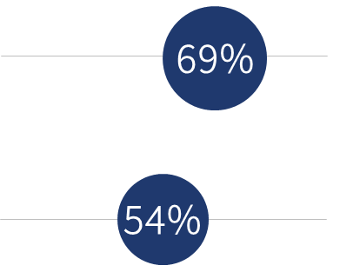 | 70%* | 70%
NEW | The diversity of content offered by lawful services is better than what can be found through illegal offers |  | 45% | 56%
*When adding up people who accessed content illegally and people who did not, the total does not equal the overall EU sample as 3% of the Europeans surveyed preferred not to answer this question. That is why we observe a difference between the percentage of people agreeing with the statement and this split shown between declared infringers and non infringers

The belief that lawful services offer higher quality content than illegal sources is most prevalent among the younger generations, as three quarters of those aged 15 to 24 and 25 to 39 stated this opinion. The youngest generation also finds that lawful services have more diverse content than illegal options, as 6 out of 10 of the respondents aged 15 to 24 state this belief, whereas a little more than half of those aged 25 to 39 share this view.
The opinion that legal offers provide higher quality content is shared by both infringers (70 %) and non-infringers (70 %). In terms of diversity of content, infringers are the least likely to view legal offers as superior to illegal sources. A total of 45 % of the respondents who have accessed content illegally believe legal platforms have more diverse content, while 56 % of non-infringers share this belief .

AVAILABILITY OF AFFORDABLE CONTENT IS THE PRIMARY REASON THAT WOULD MAKE COPYRIGHT INFRINGERS STOP ACCESSING CONTENT VIA ILLEGAL SOURCES

Among respondents admitting to using illegal sources to access online copyright content, price and availability prevail as the apparent driver for such behaviour: 71 % of Europeans surveyed mention ‘availability of affordable content from legal sources’ as the main reason that would make them stop engaging in illegal behaviour. The availability of affordable content from legal offers as the top reason for stopping the behaviour is most strongly cited by respondents in the following categories: respondents aged 25 to 39 (74 %), employed (76 %), living in large urbanised cities (75 %), the most educated (72 %), which is in line with the profile of a typical online user.

Avenida de Europa, 4, E-03008 Alicante, Spain

EUROPEAN CITIZENS AND INTELLECTUAL PROPERTY:
PERCEPTION, AWARENESS, AND BEHAVIOUR

EXECUTIVE SUMMARY

These two aspects were not surveyed in the 2013 report.
This is a new statement for Question 7 in the 2016 survey. Q7: For each of the following statements regarding lawful services offering content protected by copyright and related rights (e.g. music, films) on the internet please indicate whether you totally agree, tend to agree, tend to disagree or totally disagree.

